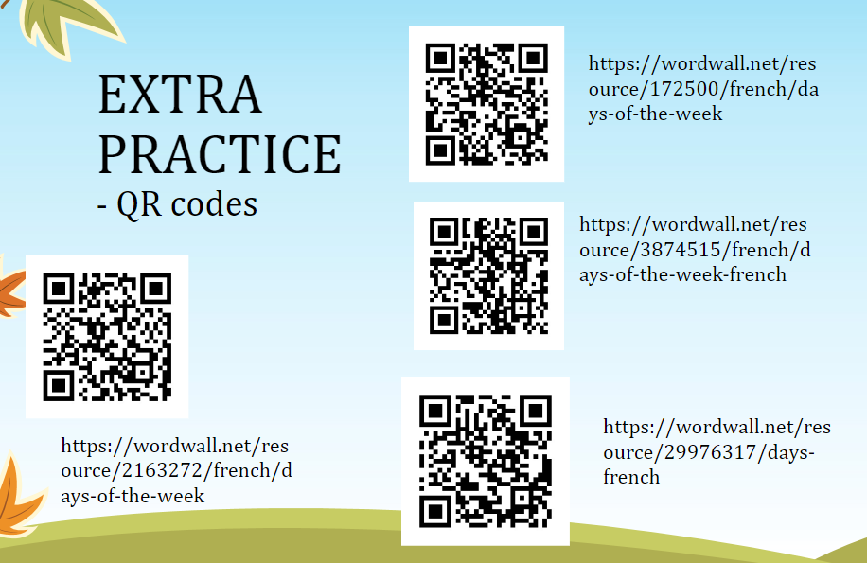

Signed: ........................................................... Date: ....................................................